Real-time AC Power Monitoring System using Arduino and pzem-004t.

Overview of the project:
To measure the real-time AC power monitoring system that enables us to monitor the voltage, current, power and power factor of the load which is connected across the AC supply using pzem-004t sensor and Arduino UNO as microcontroller.

Components Used:

Hardware:
- Arduino UNO R3 microcontroller-1
- PZEM-004t sensor module-1
- 16x12c LCD module- 1
- Load (LED, Fan, Any electrical devices)
- Connecting wires- required
- Soldering iron (For placing wires) *

Software:
- Arduino IDE

Libraries used:
- LiquidCrystal by Arduino, Adafruit.
- PZEM004Tv30 by Jakub Mandula.

Software setup:
- Install Arduino IDE from the browser and open the software.
- Select Arduino UNO by Select other boards and ports Arduino UNO from the dropdown menu and select the port in which the USB is connected to your device such as (COM4, COM5, COM6.).
- Install the libraries from the Sketch Include Library Manage Libraries... (Or press Ctrl+Shift+I).
- Search for the libraries mentioned above and install them, ensure that you are installing the updated version and the correct author name.
*Note: The soldering iron used should be temperature variable model, if any other non-temperature varying soldering iron may cause the PCB damage. Operate under low temperature with the PCB.

Programming Language:
- C++

Setup of components:
- Make connections as per the circuit diagram given below.
- Make sure that the safety precautions as it works on AC voltage.
- Make sure that the AC supply is insulated properly and the pzem-004t sensor is protected from short circuit.
- Ensure the 16x12c LCD with i2c module is connected properly with the Microcontroller.
- Make sure that the serial monitor of the Arduino IDE is set to 9600 baud rates for smooth communication from the pzem module to the microcontroller.

Circuit Diagram:
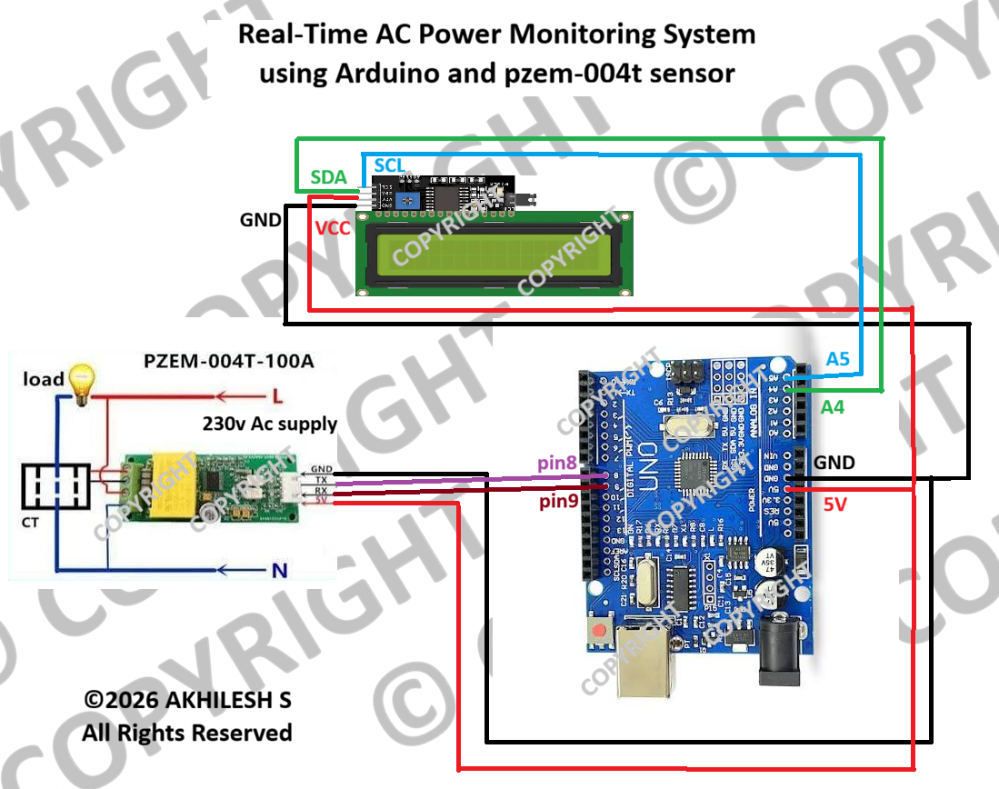

Code for Arduino IDE:

#include <SoftwareSerial.h>
#include <PZEM004Tv30.h>
#include <Wire.h>
#include <LiquidCrystal_I2C.h>

#define PZEM_RX_PIN 8
#define PZEM_TX_PIN 9

SoftwareSerial pzemSWSerial(PZEM_RX_PIN, PZEM_TX_PIN);
PZEM004Tv30 pzem(pzemSWSerial);

LiquidCrystal_I2C lcd(0x27, 16, 2);

float voltage, current, power, energy, frequency, pf;
unsigned long lastDisplayTime = 0;
const unsigned long DISPLAY_INTERVAL = 2000;

void setup() {
Serial.begin(9600);

lcd.begin();
lcd.backlight();

lcd.setCursor(0,0);
lcd.print("PZEM Meter Ready");
delay(1500);
}

void loop() {
voltage = pzem.voltage();
current = pzem.current();
power = pzem.power();
energy = pzem.energy();
frequency = pzem.frequency();
pf = pzem.pf();

if (millis() - lastDisplayTime >= DISPLAY_INTERVAL) {
lcd.clear();

if (isnan(voltage)) {
lcd.setCursor(0, 0);
lcd.print("PZEM Error!");
lcd.setCursor(0, 1);
lcd.print("Check wiring");
else {
lcd.setCursor(0, 0);
lcd.print("V:");
lcd.print(voltage, 1);
lcd.print("V I:");
lcd.print(current, 2);
lcd.print("A");

lcd.setCursor(0, 1);
lcd.print("P:");
lcd.print(power, 1);
lcd.print("W PF:");
lcd.print(pf, 2);
}

lastDisplayTime = millis();
}

Serial.print("V: "); Serial.print(voltage, 1);
Serial.print("V I: "); Serial.print(current, 2);
Serial.print("A P: "); Serial.print(power, 1);
Serial.print("W PF: "); Serial.println(pf, 2);

delay(100);
}

Code breakdown:

#include <SoftwareSerial.h>
#include <PZEM004Tv30.h>
#include <Wire.h>
#include <LiquidCrystal_I2C.h>
//===== The above lines are the header of the code that initializes the code for the process and components =====

#define PZEM_RX_PIN 8 // Arduino RX (listens) – connect to PZEM TX
#define PZEM_TX_PIN 9 // Arduino TX (speaks) – connect to PZEM RX
// ===== PIN DEFINITIONS (MATCHING YOUR WIRING) =====

SoftwareSerial pzemSWSerial(PZEM_RX_PIN, PZEM_TX_PIN);
PZEM004Tv30 pzem(pzemSWSerial);
// ===== OBJECTS (serial monitor and pzem) =====

LiquidCrystal_I2C lcd(0x27, 16, 2);
// LCD I2C – try 0x27 or 0x3F if this doesn't work

unsigned long lastDisplayTime = 0;
const unsigned long DISPLAY_INTERVAL = 2000;
// ===== VARIABLES =====

void setup() {
Serial.begin(9600);

// For your library version, just call begin() with no arguments

lcd.begin();
lcd.backlight();

lcd.setCursor(0,0);
lcd.print("PZEM Meter Ready");
delay(1500);
}

//=====This enables the lcd display=====

void loop() {
voltage = pzem.voltage();
current = pzem.current();
power = pzem.power();
energy = pzem.energy();
frequency = pzem.frequency();
pf = pzem.pf();
//=====This measures the voltage, current, power, energy, frequency, and power factor of AC load====

if (millis() - lastDisplayTime >= DISPLAY_INTERVAL) {
lcd.clear();

if (isnan(voltage)) {
lcd.setCursor(0, 0);
lcd.print("PZEM Error!");
lcd.setCursor(0, 1);
lcd.print("Check wiring");
else {
//===If there is any lag or voltage doesn’t meet the conditions the lcd shows error to check wirings properly===

lcd.setCursor(0, 1);
lcd.print("P:");
lcd.print(power, 1);
lcd.print("W PF:");
lcd.print(pf, 2);
}

lastDisplayTime = millis();
}
//This shows the output in the lcd monitor and refresh every millisecond

Serial.print("V: "); Serial.print(voltage, 1);
Serial.print("V I: "); Serial.print(current, 2);
Serial.print("A P: "); Serial.print(power, 1);
Serial.print("W PF: "); Serial.println(pf, 2);

//This is for the serial monitor which is in-built in Arduino IDE for debugging any error in the lcd module

NOTE: While checking on the serial monitor in ARDUINO IDE set the baud rate at 9600 for clear communication from pzem to serial monitor

Error shown by the serial monitor when AC supply is not given:

V: nanV I: 0.00A P: 0.0W PF: 0.00
V: nanV I: 0.00A P: 0.0W PF: 0.00
V: nanV I: 0.00A P: 0.0W PF: 0.00
V: nanV I: 0.00A P: 0.0W PF: 0.00
V: nanV I: 0.00A P: 0.0W PF: 0.00
V: nanV I: 0.00A P: 0.0W PF: 0.00
V: nanV I: 0.00A P: 0.0W PF: 0.00

Result:
Output shown by the serial monitor of Arduino IDE when AC supply is given,
V: 217.0V I: 0.30A P: 4.2W PF: 0.06
V: 217.0V I: 0.30A P: 4.2W PF: 0.06
V: 217.0V I: 0.30A P: 4.2W PF: 0.06
V: 217.3V I: 0.05A P: 2.3W PF: 0.20
V: 217.3V I: 0.05A P: 2.3W PF: 0.20
V: 217.3V I: 0.05A P: 2.3W PF: 0.20

Conclusion:
In this mini-project, a functional and efficient Real-time AC Power Monitoring System was successfully designed and implemented using the Arduino microcontroller and the PZEM-004T sensor.
Through this project, the core objectives of safely interfacing an AC load with digital microelectronics were achieved. The PZEM-004T sensor proved to be a highly accurate and reliable module for isolating and measuring critical electrical parameters—including voltage, current, active power, frequency, and power factor. Utilizing Arduino allowed for seamless data processing and provided a foundation for real-time data visualization.
Ultimately, this project highlights the feasibility of building cost-effective, non-intrusive smart energy monitoring solutions. Such systems are crucial in promoting energy awareness, optimizing power consumption, and identifying electrical anomalies in both domestic and industrial environments.

Author & project information:
Parameter | Details
Developer | AKHILESH S
Role / Focus | Electrical Engineering Student/ Embedded systems & IoT
Project Type | Hardware Prototyping & Energy Analytics (Mini-Project)
Key Technologies | Arduino, PZEM-004T Sensor, UART Communication, C++
Contact / Portfolio | akhilesh24590@gmail.com, linkedin.com/in/akhilesh4747.

*****END OF REPORT*****

